VOCABULARY AND GRAMMAR
EXERCISE & PRACTICES

2.2

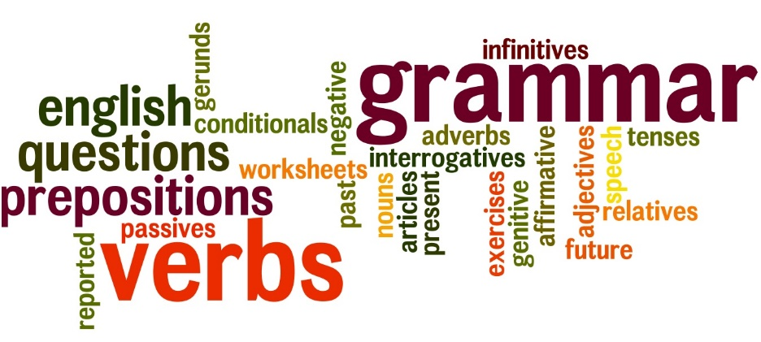

NAME: ___________________ PD.: ____
TEACHER: __________________________

EXERCISE 5: GRAMMAR
Directions: Write one sentence using an example of each time of adverb listed below. (Use the adverbs you charted on Exercise 3 in your sentences to help guide you!)
ADVERB OF TIME: ________________________________________
_______________________________________________________
_______________________________________________________
_______________________________________________________
ADVERB OF PLACE: _______________________________________
_______________________________________________________
_______________________________________________________
_______________________________________________________
ADVERB OF MANNER: ____________________________________
_______________________________________________________
_______________________________________________________
_______________________________________________________
ADVERB OF DEGREE: ______________________________________
_______________________________________________________
_______________________________________________________
_______________________________________________________

EXERCISE 2: VOCABULARY
Directions: Write the correct vocabulary word from 2.2 in the blank.
- ___________________ strength and energy of body or mind; strength of concentration; force of energy
- ___________________ give pleasure or satisfaction’ to give in to
- ___________________ able to be skilled in many things; adaptable to many uses or situations
- ___________________ based on legends or stories handed down from one generation to another; traditional; famous
- ___________________ to reach a definite decision; to find a solution; to explain or make clear; to change or transform
- ___________________ very important
- ___________________ a collection of myths or stories, usually about gods and their relationships to human beings; the study of myths
- ___________________ in agreement; able to coexist; holding regularly to the same rules
- ___________________ absolutely essential; necessary
- ___________________ to love or to hold dear; to take care of; to protect

EXERCISE 3: GRAMMAR
Directions: Below is a word bank of adverbs. Place them in the correct place on your chart below.
YESTERDAY REALLY LAZILY THERE SOON OVER CAREFULLY DAILY
NERVOUSLY HURRIEDLY FORWARD HERE
VERY EVERYWHERE ALMOST
TOMORROW HARDLY BEFORE BRILLIANTLY
TIME (answers when) :

PLACE (answers where):

MANNER (answers how):

DEGREE (answers to what extent):
EXERCISE 4: VOCABULARY
Directions: Select the word that means the opposite or about the opposite, of the bolded vocabulary word from each question below.
- To cherish the toys
  - destroy c. hold dear
  - buy d. polish

- a crucial moment
  - serious c. cheap
  - elegant d. unimportant

- to gratify his demands
  - give in to c. thank
  - ignore d. reveal

- an indispensable part
  - repaired c. broken
  - important d. unnecessary

- with vigor
  - strength c. weakness
  - money d. desire

EXERCISE 1: GRAMMAR
ADVERBS
Directions: Fill in the blanks based off your notes from VG 2.2
ADVERBS – _________________________________________
___________________________________________________
Adverbs fall into FOUR types or classes:
_______________ (answers _____________________)
_______________ (answers _____________________)
_______________ (answers _____________________)
_______________ (answers _____________________)
EXAMPLES:
TIME: ____________________
PLACE: ___________________
MANNER: ________________
DEGREE: _________________

EXERCISE 6: VOCABULARY
Directions: Select the word that means the same or about the same, of the bolded vocabulary word from each question below.
- An approach consistent with mine
  - competing c. in agreement
  - in disagreement d. terrible

- to designate a captain
  - obey c. select
  - talk about d. report to

- Asian mythology
  - study c. group of myths
  - legendary hero d. kingdom

- to show resolve
  - problems c. doubt
  - determination d. fear

- a versatile football player
  - especially strong c. well-known
  - confused d. well-rounded

