VOCABULARY AND GRAMMAR
EXERCISE & PRACTICES

1.2(A)

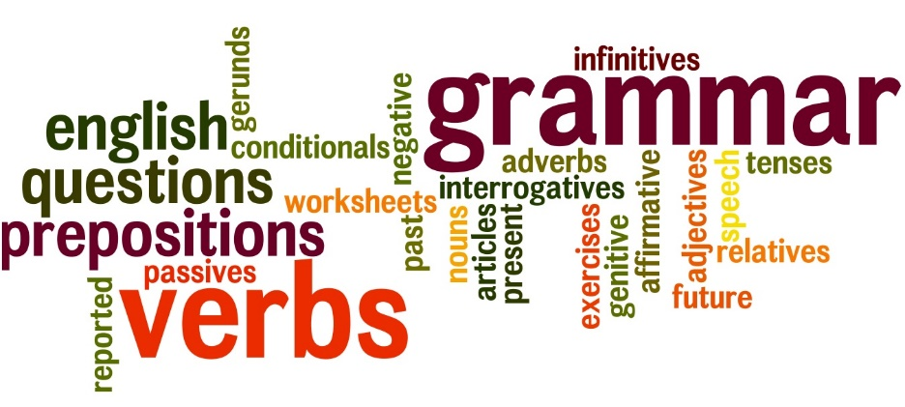

NAME: ___________________ PD.: ____
TEACHER: __________________________

EXERCISE 1: VOCABULARY
Directions: Write the vocabulary word that best matches the definition provided in the space below.
- __________________ : adj. giving light; glowing in the dark; easily understood.
- __________________ : v. to put under a spell; to bewitch; to hold motionless; to charm or captivate
- __________________ : v. to unite persons or groups; n. a country, person or group joined for a common purpose; a plant, animal, or thing related to another; a helper
- __________________ : adj. feeling from danger, justice, and so on; fleeting; n. a person who flees or has fled; a fleeting thing
- __________________ : n. the inevitable order of events; fate
- __________________ : v. to enter as an enemy; to intrude in
- __________________ : n. an offer; a show of willingness to deal; an introduction to an opera or other long musical work; any introductory section.
- __________________ : v. to turn away; to keep from happening
- __________________ : n. movement of part of the body to express something; something said or done as a formality only; v. to express an idea or emotion with movement.
- __________________ : adj. of stars; superior; leading
EXERCISE 2: GRAMMAR
SUBJECTS AND PREDICATES
Directions: Underline each subject (what the sentence is about) with one line and each predicate (what “act” the subject(s) is doing) with two lines. In each sentence, the subject or predicate may be simple or compound.
- Jim came in and sat down.

- Molly and I watched a video.

- Jonathan logged on and checked his e-mail.

- He got an e-mail from his cousins in Tokyo.

- Andrew and Hannah wrote about life in Japan.

- They still play baseball and go to the movies.

- They ride a train, instead of a bus, to school.

- Hannah reads and writes in Japanese.

- Andrew can speak Japanese and Mandarin.

- Jason and Mason block and tackle for a living.

EXERCISE 3: GRAMMAR
SUBJECTS AND PREDICATES
Directions: All the following sentences have a compound subject, a compound predicate, or both. Underline each subject with one line and each predicate with two lines.
- Slick roads or heavy traffic sometimes makes us late for school.
- The teacher went to the board and started writing.
- Our neighbors went to the Grand Canyon and hiked for a week.
- They took pictures and brought back postcards.
- Shannon and I heard all about their trip.
- After dinner, Ross and Lindsey do their homework and play computer games.
- Summer and fall are my favorite times of year.
- Snow or ice on the roads slows traffic and makes driving dangerous.
- Earth orbits the sun and rotates on its axis.
- Neptune and Pluto are farther from the sun and colder than Earth.

EXERCISE 4: VOCABULARY
Directions: For each item below, circle the letter of the choice that means the opposite (Antonym), or about the opposite, of the boldface word.
- To find an ally
  - Friend c. Enemy
  - Pathway d. Place

- To avert the danger
  - Avoid c. Prevent
  - Cause d. Describe

- To invade the house
  - Retreat from c. Build
  - Burn Down d. Enter

- A stellar performance
  - Demanding c. Weak
  - Excellent d. Opening

- To fascinate the crowd
  - Bore c. Tease
  - Interest d. Amuse

