VOCABULARY AND GRAMMAR
EXERCISE & PRACTICES

1.4

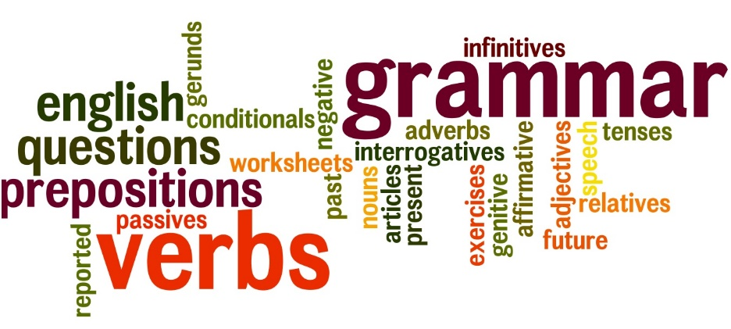

NAME: ___________________ PD.: ____
TEACHER: __________________________

EXERCISE 4: GRAMMAR
Directions: In each of the following sentences, underline the verb with one line. If the sentence contains a helping verb, underline that verb twice.
- However, the gymnasium at Fillmorton Recreation Center had become a disaster area.
- Three students had been selected as the cleanup committee.
- They were moving slowly through the debris on the gym floor.
- They found Moe Epstein’s baseball cap.
- He may have lost it during his dance with Sasha Seabury.
- Earlier, they had discovered Rachel Sveum’s retainer under a heap of crepe-paper streamers.
- She probably lost it during the swing contest.
- That may have been the highlight of the dance.
- “Your lousy dancing started a storm, Larry!”
- Everyone laughed at the joke, including Larry.
EXERCISE 1: VOCABULARY
Directions: For each item below, circle the letter of the choice that means the same (synonyms), or about the same, as the boldface word.
- The consequences of an action
  - Complaint c. Result
  - Illness d. Thought

- To conform to standards
  - Adapt c. Avoid
  - Ignore d. Disagree With

- To distort her words
  - Listen to c. Laugh at
  - Record d. Twist

- A moment of originality
  - Creativity c. Joy
  - Loss d. Hunger

- Events that impact daily life
  - Change c. Confuse
  - Delight d. Dignify

EXERCISE 2: GRAMMAR
Directions: In each of the following sentences, underline the verb with one line. If the sentence contains a helping verb, underline that verb twice.
- Everyone should stay and help with the cleanup.
- But Rick reminded us that a storm was coming and we had planned to walk home.
- Larry said he could call his dad.
- “Maybe he can drive us home.”
- Larry called home, but no one answered.
- Just then, we heard thunder.
- A blast of wind cut through the gym and blew trash everywhere.
- “Okay, I am not walking home in a storm,” Debbie said.
- We were wondering what to dod when Larry yelled, “Dad!”
- We all looked up and saw Larry’s dad in the car right outside the gym door.

EXERCISE 3: VOCABULARY
Directions: For each item below, circle the letter of the choice that means the opposite (antonyms), or about the opposite, as the boldface word.
- A deliberate choice
  - Accidental c. Important
  - Well thought out d. Unlucky

- Excess TV watching
  - Extra c. Not enough
  - Entertaining d. Supervised

- To offend the audience
  - Upset c. Please
  - Worry d. Interest

- An Interest in reality
  - Life c. Death
  - Fantasy d. Property

- To recoil suddenly
  - Advise c. Avoid
  - Run away from d. Come forward

