VOCABULARY AND GRAMMAR
EXERCISE & PRACTICES

1.3

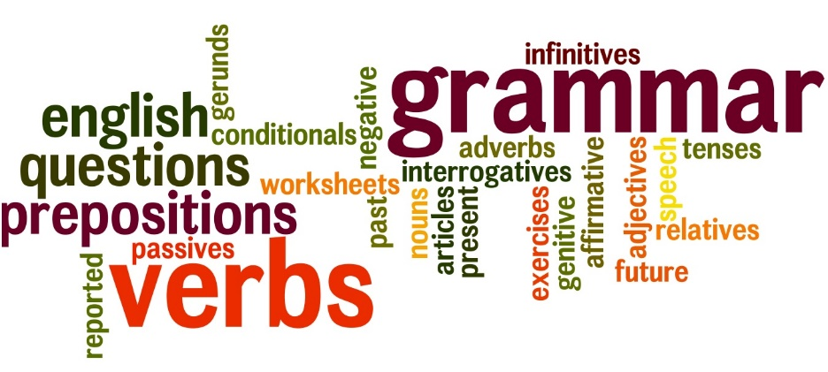

NAME: ___________________ PD.: ____
TEACHER: __________________________

EXERCISE 4: VOCABULARY
Directions: Fill in the blank with the vocabulary word from Vocabulary 1.3 that best fits in the blank. Use context clues from the sentence to help you figure it out!
We could talk about dance in ______________ or general terms, but it’s more interesting to talk about specific dances and dancers. An older generation often thinks that a younger generation’s dances are ______________. But, just as often, the younger generation thinks that their elders’ dancers are ridiculous. Dance styles change, but the arguments they cause stay around. The Charleston was just as _________________ in the 1920s as break dancing was in the 1980s.
Today, few people would say that the Charleston, the Jitterbug, or the Twist are ______________, but when these dances were popular, with the young, many parents thought them bizarre. To some people the difference in dance styles doesn’t seem to be a __________ question of taste. The issue isn’t that simple to them.
No one likes to feel that his or her way of doing things has become old-fashioned, or _________________, like a horse-drawn carriage.
Each generation feels a little ______________ when it hears its styles of dance criticized. Every generation resists the views of the previous generation. One good __________________ for avoiding conflict is to ask parents whether they ever had this discussion with their parents. Actually, one generation’s dances probably are neither ______________ to nor better than another’s. They’re just different. The _______________ result of time passing is that whatever dance style is “in” will soon become dated.
EXERCISE 1: GRAMMAR
VERBS – ACTION AND LINKING
Directions: Underline the verbs with one line in the following sentences. Label each verb with an “A” for action or an “L” for linking. Some sentences may contain more than one verb.
A
- Nearly everyone knows about the great Chicago fire of 1871.
- On the same night, an even more terrible fire roared through Peshtigo, Wisconsin, 250 miles north.
- A the time, Peshigo seemed safe, like any other busy logging town.
- The summer and fall of 1871 were usually hot and dry throughout the area.
- During the night of October 8, numeroug small fires started in the dry forests around Peshigo.
- Fire brigades worked as hard and as fast as possible.
- But suddenly the situation grew far worse.
- The sound of an enormous, raging forest fire reached the ears of the terrified residents of Peshtigo.
- In the darkness and confusion, people panicked and ran in all directions.
- Two different groups of people dashed toward the river from two directions and met on a small bridge.
EXERCISE 2: GRAMMAR
VERBS – ACTION AND LINKING
Directions: Underline the verbs with one line in the following sentences. Label each verb with an “A” for action or an “L” for linking. Some sentences may contain more than one verb.
A
- The students entered the dance through the gym door.
- The decorations were colorful streamers of crepe paper.
- Our dance began right after school.
- The theme of our dance was “Friends Forever.”
- Most of the students attended the dance.
- Our disc jockey played a lot of oldies.
- Most of us were very nervous at the beginning of the dance.
- One of the chaperons arranged us in pairs to dance.
- Larry and Jack hid from the “matchmaker”
- Robert was the only nondancer in the group.

EXERCISE 3: VOCABULARY
Directions: Write the correct word in the space for each definition from Vocabulary 1.3.
- ___________________ happening at the end of, or as a result of, a series of events; ultimate, final
- ___________________ distorted; bizarre; absurd; a hideous or fantastic thing or quality
- ___________________ lower in importance, rank, order, or status
- ___________________ causing argument; debatable
- ___________________ nothing more or other than; only
- ___________________ openly and boldly resisting
- ___________________ a way of using skills to achieve a task; a technical skill; a way of doing something
- ___________________ so untrue or unreasonable as to be ridiculous
- ___________________ out-of-date; no longer used
- ___________________ not concrete; theoretical; a summary, nonrepresentational

