VOCABULARY AND GRAMMAR
EXERCISE & PRACTICES

2.1

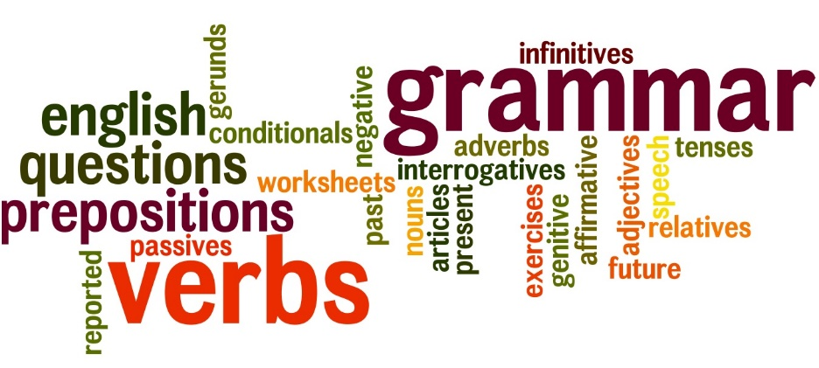

NAME: ___________________ PD.: ____
TEACHER: __________________________

EXERCISE 5: GRAMMAR
Directions: In each of the following sentences, underline each adjective in the sentence and circle the noun in modifies.
- There are many frightening and mysterious bats in the world.
- Many people find bats to be scary.
- The world has small bats, but they eat plenty of insects.
- Bats are nocturnal mammals that fly at night.
- A bat’s webbed wings and big ears look unusual to people.
- A healthy respect is good because bats can be rabid.
- Bats are valuable because they prey on mice, mosquitoes, and other pests, too!
- Through environmental damage, some bat species became rare in the 1980s.
- Scientists appear concerned that the disappearance of bats could be upsetting to the earth’s ecology.
- Bats are also useful for spreading fruit seeds, pollen from flowers, and tree seeds.

EXERCISE 2: VOCABULARY
Directions: Write the correct vocabulary word from 2.1 in the blank.
- ___________________ very deep; very serious
- ___________________ a traditional story used to explain the world of human behavior; usually fiction
- ___________________ to look very closely; to think carefully about; to consider
- ___________________ based on legends or stories handed down from one generation to another; traditional; famous
- ___________________ consisting of two parts; double
- ___________________ to explain the meaning of; to translate; to show one’s own understanding of
- ___________________ living forever; having lasting fame
- ___________________ according to set rules or customs; stiff in manner; done or made in an orderly manner
- ___________________ alike enough to be compared; worthy of comparison
- ___________________ trustworthy; reliable; genuine, real

EXERCISE 3: GRAMMAR
Directions: In each of the following sentences, underline each adjective in the sentence and circle the noun in modifies.
- Annie was a silly girl who liked to play checkers during the hot summer.
- There were twelve alligators in the muddy swamp down in Louisiana.
- Stinky boys can make a small classroom smell really bad!
- During the cold winter, I like to curl up with a glass of warm milk, chocolate-chip cookies, and read a mystery book.
- The wool blanket can make me feel itchy.
- Grandpa always smells like peppermint candy.
- Craig wrote a short story about his friends that ended up being true!
- Football can be a tough sport.
- Algebra class is very boring, but I have a nice teacher.
- I love eating pepperoni pizza.

EXERCISE 4: VOCABULARY
Directions: Select the word that means the opposite or about the opposite, of the bolded vocabulary word from each question below.
- An authentic document
  - legal c. genuine
  - similar d. fake

- a formal occasion
  - serious c. frightening
  - casual d. happy

- the immortal movie star
  - forgotten c. talented
  - famous d. wealthy

- a dual interest
  - single c. double
  - sincere d. cruel

- a profound idea
  - confusing c. deep
  - lost d. shallow

EXERCISE 1: GRAMMAR
ADJECTIVES
Directions: Fill in the blanks based off your notes from VG 2.1
_______________________ – used to __________________ a person, place, thing, or idea. In other words, adjectives are used _____________________________________________!
Adjectives will answer the following questions:
- _________________ 2. _________________
3. __________________ 4. __________________
EXAMPLES:
SMART GIRL TALL GREEN TREE
WISHFUL THOUGHT GREAT STATE OF TEXAS
PRACTICE:
(Underline the adjectives(s) in the sentences below once and circle the noun it describes.)
- Anna eats her green grapes at lunch.
- The long, warm scarf kept me from getting sick.
- The track runners were faster than lightning.

EXERCISE 6: VOCABULARY
Directions: Select the word that means the same or about the same, of the bolded vocabulary word from each question below.
- At a comparable price
  - costly c. reliable
  - similar d. unusual

- to contemplate a question
  - answer c. think about
  - ask about d. color in

- to interpret a speech
  - explain c. memorize
  - confuse d. forget

- a legendary title
  - passed down c. ignored
  - lost in time d. forgotten

- to question a myth
  - modern song c. scientific proof
  - legendary monster d. popular belief

